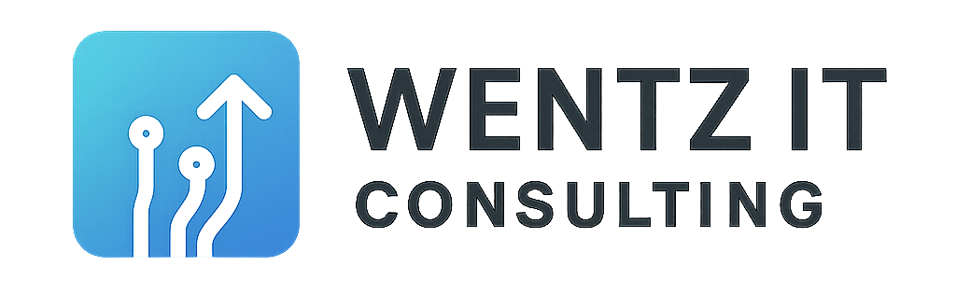

📋 Email Protection Checklist for Business Owners
Not sure if your domain is protected from spoofing or impersonation?
Use this non-technical checklist to ask the right questions — whether you're working with Mailchimp, HubSpot, Constant Contact, or any other email tool.

✅ Domain Verification
- ☐ Have I verified my domain in my email platform?
- ☐ Does the platform show that I'm authorized to send from my domain?

✅ Security Setup
- ☐ Has my tech provider set up SPF and DKIM records for my domain?
- ☐ Has someone confirmed those records are working properly?

✅ Campaign Testing
- ☐ Have I sent a test campaign to myself?
- ☐ Did the test go to my inbox — or did it land in spam?

✅ Peace of Mind
- ☐ Do I have someone I can call if something looks off?
- ☐ Do I get reports if someone tries to fake my domain?
🔐 Need help? I can review your email setup and walk you through any changes needed — fast, clear, and jargon-free.

