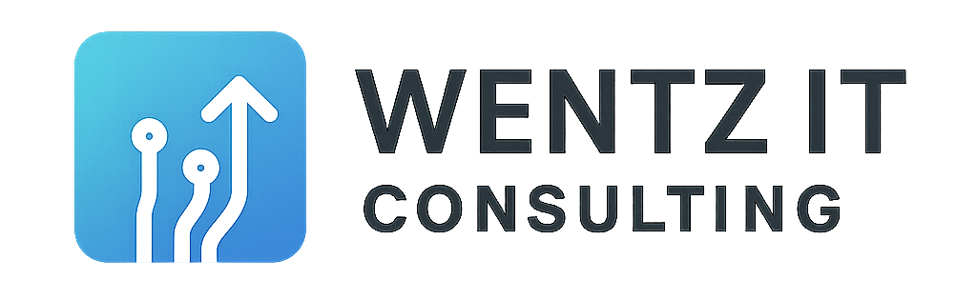

# Passkey Upgrade Readiness Checklist

Google is moving away from traditional passwords and SMS-based 2-step verification. This checklist will help you prepare your business or personal accounts for this change—without the jargon.

## 🔐 Get Your Devices Ready

☐ Make sure your phone, tablet, or computer supports passkeys.

☐ Install the latest updates for your operating system and web browser.

☐ Set up a secure screen lock like fingerprint, Face ID, or a strong PIN.

## 👥 Update Your Google Account

☐ Visit https://g.co/passkeys to turn on passkeys for your account.

☐ Save a passkey on your main device.

☐ Add a backup method in case you lose your phone or computer.

## 🛡️ Keep It Secure

☐ Remove any old or unused devices from your Google account.

☐ Check that your recovery options (email, phone number) are current.

☐ Let your staff or family members know this change is coming.

## ✨ Extra Credit (Optional)

☐ Use a passkey manager that syncs across your devices.

☐ Turn on passkeys for other accounts like Amazon or Microsoft.

☐ Make a simple guide for your staff if you're managing a team.

Still have questions? We’re happy to help walk you through it. Reach out to Wentz IT Consulting at our contact us page, <https://wentzitconsulting.com/contact-us/>.

You can also read more from Forbes: <https://www.forbes.com/sites/zakdoffman/2025/06/21/google-confirms-most-users-must-upgrade-gmail-and-other-accounts/>